Student’s name | …………………………………………………….…… | Grade | 6
Subject | Computer | Week No. | 1
Quiz No. ( 1 ) (Answer)
10

write the correct name of each part.



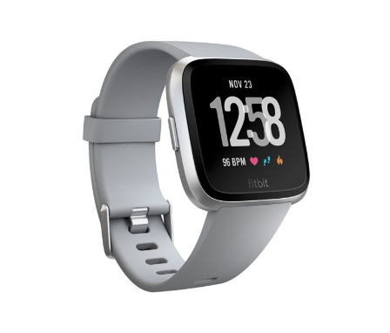
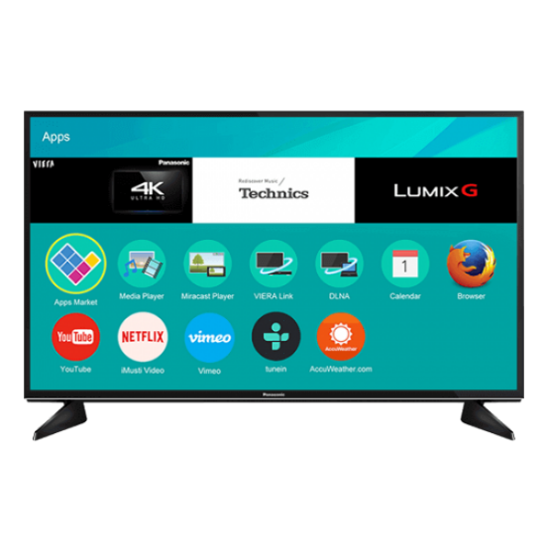
Calculator
CLI
Smart watch
Smart TV
Smart watch
Smart TV
Calculator
Vector TV
CLI
Good Luck

